Recipient of the AANO’s
“2018 Lifetime Achievement Award”

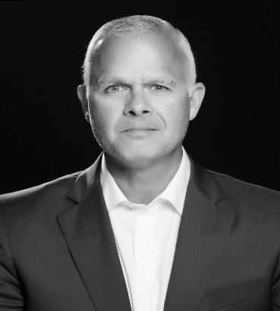
COL Christopher P. Costa, USA, (Ret)
Mr. Costa served as the Special Assistant to the President and Senior Director for Counterterrorism on the National Security Council (NSC). At the NSC, he was responsible for coordinating counterterrorism policy and strategy as well as U.S. hostage recovery activities. Mr. Costa had 34 years of progressive national security experience and well-documented success in strategy, policy, special operations, counterintelligence, and human intelligence, deploying on multiple contingencies and to combat operations in the Republic of Panama, Afghanistan, and Iraq. Mr. Costa's last assignment with the United States Special Operations Command (USSOCOM) was as Program Director in the Operations Directorate. Preceding USSOCOM, Mr. Costa served as a Department of the Navy civilian at the Naval Special Warfare Development Group – with US Navy SEALs, and as a Senior Adjunct Instructor with Norwich University's Bachelor of Science in Strategic Studies and Defense Analysis Program; with Norwich University, he taught on topics related to national security, strategy, and counterterrorism. He holds an M.A. in Strategic Intelligence from American Military University; an M.A. in National Security and Strategic Studies from the U.S. Naval War College; and a B.A. from Norwich University. His military awards and decorations include the Defense Superior Service Medal, Legion of Merit, and two Bronze Stars. In May 2013, Mr. Costa was inducted into USSOCOM’s Commando Hall of Honor for extraordinary and enduring service to Special Operations Forces. Most recently, Mr. Costa joined the International Spy Museum as the Executive Director where he will play a leading role in building on its extraordinary success as a Washington attraction and speaking responsibly on current counterterrorism and intelligence issues.

